Saturday, 12 September 2026, postcard

Fragonard, Paris to Lyon at high speed, then board MS Lumiere

All three of us managed to get up, get our luggage ready for pick-up by 7 am. Rachel and I then had breakfast and prepared for a morning excursion. David went back to bed.

This was originally billed as a morning in Paris, but at the last minute, Tauck added an optional (but included) tour of the nearby Fragonard perfume museum. It was founded not by Honoré Fragonard, the inventor of plastination, nor by his cousin Jean-Honoré Fragonard, the Rococco painter (both of whom were born in Grasse, center of the perfume world), but by some guy named Fuchs (based in Grasse) who was a great fan of the latter and named the company after him.

Our charming young guide, a Fragonard employee, explained the "structure" of perfumes, including the "top notes," "middle (or "heart") notes," and "base notes," as well as outlining the process of distillation that extracts aromatic oils from flowers, spices, and whatnot that come from all over the world.

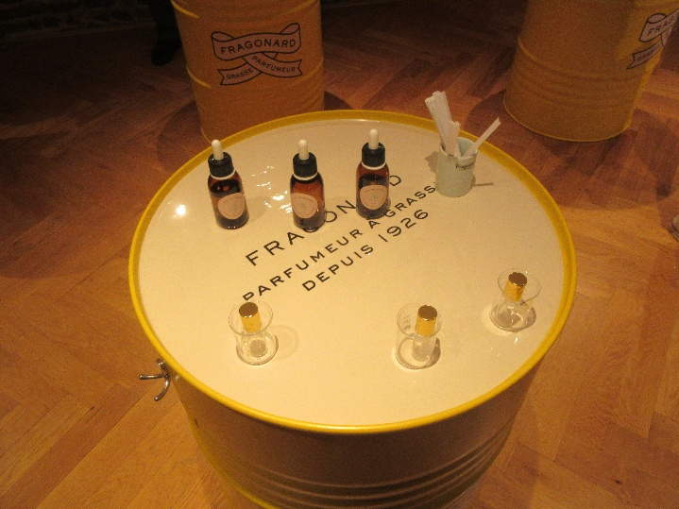
Then he talked a little about the history of perfumes and their containers before ushering us into a space where we were provided with three premixed blends of top, middle, and base notes; a little beaker in which to mix them, paper strips to dip and sniff, and a little atomizer bottle into which to pour our blend to take home. (Here, the atomizers are sitting inside the beakers.) Rachel and I used droppers from the premixed bottles to experiment with our blends (she made two, one for each granddaughter).

Finally he led us to the "tasting room," where he let us sniff a variety of Fragonard products with a view to selling us some—four sizes of bottle (with a large or a box of four, you got complimentary atomizers for use while traveling). To demonstrate a scent, he fanned a pack of paper strips printed with the appropriate perfume name, sprayed them liberally, then handed them out to everyone. Other salespeople at other tables were doing the same thing, and all the potential customers ended up with whole bouquets of little labeled paper strips. Rachel bought some perfumes as gifts, and I acquired a bar of honeysuckle scented soap (all the hotels and even the ship just provide shower gel these days, which I dislike). By the time we got back to the hotel, we must have reeked!

We had time then to gather up all the belongings we intended to take with us on the train and to check out of the hotel before boarding the buses that would take us to the Gare de Lyon to board our train. While we waited for our platform to be announced, Rachel and I shopped for a picnic lunch to eat on the train (ham and cheese toasties for David and Rachel and smoked salmon sandwich for me; chocolate croissants all around).

The trip to Lyon was only a little longer than the one from London to Paris. We were met y buses at the Lyon Perrache station and ferried to MS Lumière. We boarded and settled in the lounge while waiting to be called up in turn and checked in. Our luggage was already in our cabins. The ship headed up-river on the Saône as soon as we were all aboard.

We were checked in near the end, and I barely had time to shower and change before we were due in the lounge for crew introductions and cocktails!

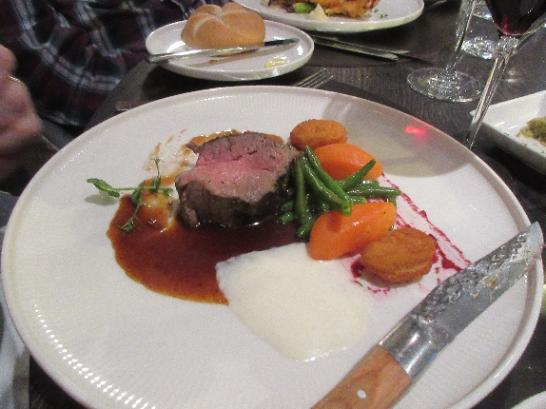
David raved about his tomato soup appetizer, and his filet-mignon main course looked pretty good too.

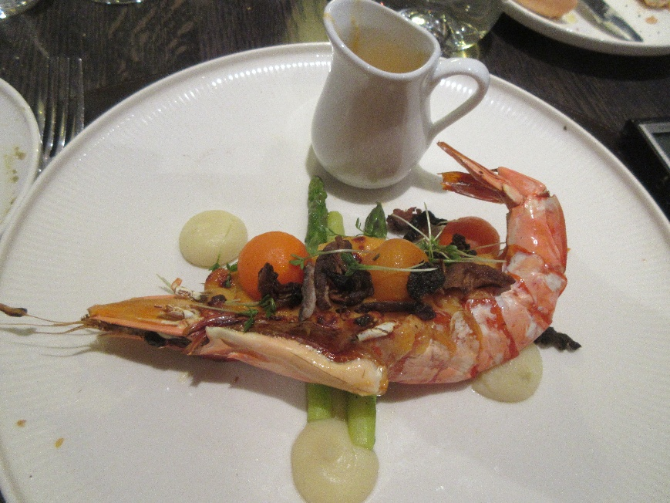
My shrimp thermidor was difficult to extract from its shell but delicious once I got it out of there.

I forget what David had for dessert, but I was very happy with my raspberry sorbet.

